**Executive Summary**

Given the ever-increasing demand for drinking coffee on the go, the demand for single-use/ disposable coffee cups cannot be looked down upon. With the increased pace of life, one cannot undermine the importance or rather the need for a cup of coffee. People tend to buy their coffee on their way to work rather than having it prepared at their homes. This is led to a tremendous increase in usage of the disposable coffee cups served by the coffee shops, leading many to ignore the harmful effects it has on the environment.

A reasonable and affordable solution to this plastic menace is promoting and encouraging people to bring their own coffee cups. Not only does it helps conserve the environment but also is a pocket-friendly solution with its own cup discount of $0.25.

We the students of Langara, as a part of our BUSM group project, undertook an awareness initiative to limit the use of disposable cups and promote bringing your own coffee cup.

Our Mission

We aim to reduce environmental waste by encouraging people to carry reusable mugs/ bottles. Our event objective is to:

* Deliver the message that instead of using non-reusable products, we have a choice to use reusable one.
* Motivate 30 - 50 participants to bring their cups.
* Encourage at least one cafe to join the campaign.

Our Team

The name of our team is “Save a Quarter”. This reminds the participants whenever they are carrying their containers, the benefit is double up. They are showing earth love and saving $0.25 cents at the same time. It is because the government requires every vendor to charge $0.25 for every single-use beverage cup in British Columbia since January 1, 2022.

Event Highlights

An online survey is specially designed to raise awareness and we distributed around 150 surveys during the event. From the data collected, we understand some students are hesitating to bring their own cups due to the lack of cleaning stations and hygiene concerns. This data can be a reference for authority to enhance sustainability in school.

Contents

1.0 Introduction & Project Background 4

1.1 Problem Statement 4

1.2 Our Aims 5

2.0 Project Definition In Details 5

2.2 Project Rationale 5

2.3 Project Strategy 6

2.4 Business benefits the project will achieve 6

2.5 Team Structure and Role 6

3.0 Stakeholder Identification, Assessment and Communication Plan 8

3.2 Stakeholder Category and Communication Plan 8

3.3 Time and Budget Estimation 9

3.4 Project Duration Estimate 9

4.0 Project Schedule & Critical Path 10

4.1 Schedule 10

4.2 Risk Management 11

5.0 Other Relevant Information 5.1 An Organizational Change Management Plan 12

5.2 Critical Path and Meditation Plan 12

6.0 Conclusions 14

6.3. Project Insights 15

6.4. Key Factor for Project Success 15

6.5. Lesson Learnt 16

7.0 Bibliography 16

1. Introduction & Project Background

Coffee is not just another drink but a necessity. Taking into consideration the environmental cost of having coffee is not something that can be ignored any longer. There seems to be an ecological and social cost attached to the use of single use/disposable cups. With the increased pace of life and an uprising demand for coffee on the go, the demand for single use coffee cups has tremendously increased. Thus, it seems compelling to look into what goes into the making of the coffee cup.

Looking into the material decomposition of the cups it seems that cup is made of a paper layer and a polyethylene layer. The polyethylene layer used to maintain the shape of the cup while keeping it heat and water resistant is non-recyclable. It is also difficult to separate the polyethylene layer from the paper layer. As per a study by UBC, about 20 million trees are cut annually to meet the demand for these paper cups. An additional 9000-12000 kg of steam 960- 1000 kWh electrical power and 50m3 cooling water is required to process these raw materials into the finished products. The most complicated issue in the recycling loop is the disposal of single-use coffee cups. Because the polyethylene layer makes it difficult to separate the plastic lining from the paper layer, recycling paper cups is problematic.

Talking about the city of Vancouver, it is estimated that about 2.6 million paper coffee cups end up in the landfill each week. In 2018, the city of Vancouver alone threw out more than 82 million single-use cups. The majority of these were not recycled and were disposed of in landfills. This not only costs taxpayers’ money in terms of rubbish collection, but it also has long-term harmful environmental consequences.

## 1.1 Problem Statement

Our main aim was to raise awareness regarding the harmful effects of disposable coffee cups that end up in landfills and release harmful gases, contributing to global warming. Paper and Styrofoam coffee cups are not recyclable, so those immediately go in the trash. Although plastic lids and cardboard sleeves are recyclable, recycling them and breaking them down into biodegradable or reusable materials consumes energy and resources.

Starting from January 1, 2022, the government announced a move to charge $0.25 for the use of disposable cups, and $0.10 for the use of paper bags. Anyone buying soft drinks, coffee, and beverages has to pay this fee. The only ones exempted are the ones using their own cups. There was little awareness amongst the people regarding this. Conducting an informal survey led us to the conclusion that people were willing to bring their own cups solely for the purpose of doing their part for the environment but were unaware of the monetary benefits associated with it. Also, many were willing to bring their own cup if they were given some incentive for the same. This led us to come up with the idea of spreading awareness amongst the small group of students and staff members within Langara college and start this campaign of change.

## 1.2 Our Aims

We aimed to host a ‘bring your own cup’ event to boost the awareness of environmental protection and aim to reduce the use of disposable cups. Our main aim is to make everyday coffee sustainable and pocket friendly.

2.0 Project Definition In Details   
2.1 Project goals and objectives

Goals: Our major goal was to raise awareness about the negative consequences of disposable coffee cups, which end up in landfills and emit toxic gases that contribute to global warming.

Project objectives:

* At least one cafe on campus is going to join the campaign.
* Deliver the message that we have the choice of using reusable products rather than non-reusable ones.
* Spread awareness to at least 30 - 50 participants in the event.
* Reduce environmental waste by encouraging individuals to always carry reusable mugs and bottles.

## 2.2 Project Rationale

* Problem: We observed that many students were carrying paper cups for their drinks around the college, and we are trying to promote the idea of using less non-reusable material to bring out a sense of sustainability. With the support of the data provided by LSU cafe, only 18% of the customers are using their own cups with 27 days of data. We hope to promote the benefit of using our own cups and the newly imposed law on reusable cups.
* Solution: We are going to build a campaign to promote Bring Your Own Cup (BYOC). Promotions will include posters, videos, social media posts (LSU Instagram post/ IE Instagram post etc.).

## 2.3 Project Strategy

Bringing your own cup has a trinity of benefits for our health, coffee quality, and the environment. As we begin to create our BYOC (bring your own cup) habit, keep the following elements in mind:

* No more toxic materials. A reusable cup made of stainless steel, glass, or BPA-free silicone is healthier for our bodies and tastes better.
* Reduce single-use plastic waste. Paper coffee cups require a tremendous amount of energy to manufacture, distribute, and dispose of. This has had an influence on our ecosystem, causing global warming and pollution.
* Most paper cups are lined with a sort of plastic that keeps the liquid from seeping out, but it also makes them unrecyclable. As a result, most of them are disposed of in landfills.

## 2.4 Business benefits the project will achieve

We can save natural resources and reduce soil pollution by raising public awareness about disposable cups and encouraging people to use their own cups. Because a portion of our garbage is disposed of in landfills, the soil is heavily polluted. Because toxic waste materials are carried through the soil and into our groundwater at some point, this type of soil pollution will eventually lead to groundwater pollution. Thus, avoiding the use of disposable cups to reduce trash generation and protect the lives of many people on our planet might be a wise decision.

## 2.5 Team Structure and Role

|  |  |  |  |
| --- | --- | --- | --- |
| Role | Response | Primary | Secondary |
| Facilitator | Define milestone and schedule  Stakeholders’ management with MMC and Shervin | Jonathan | Billy |
| Explorer | Research news and regulatory regards on BYO coffee cup | Karishma | Ashley |
| Public Relation | Manage expectations and connections with coffee shops  Explore the possible participant | Billy | Surabhi/ Jonathan |
| Langara Clubs Connector | Contact with Langara clubs  Sustainability club, MMC, LSU for marketing | Surabhi | Karishma / Billy |
| Marketing | Design Poster  Prepare QR code  LSU: Social Media, Poster location and durations | Ashley | Jonathan |
| Contributor | Share ideas, Vote  Attend meeting | All member | |

2.6 Work Breakdown Structure and Technical Requirements

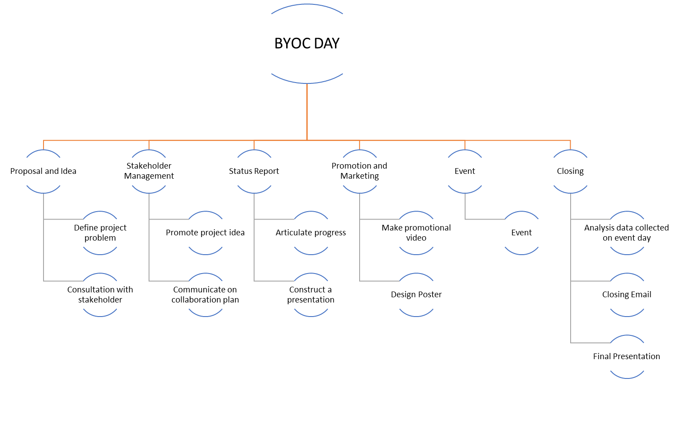

Technical Requirements

* + Communication channel, LSU, bright space, announcement
  + Poster design
  + Google Webform
  + QR code generator
  + Filming

2.7 Deliverables, Priorities, Constraints, Assumptions, Milestones

1. Deliverables
   * Designing posters for our campaign
   * Communicate with various channels on event details broadcasts
   * Promotion on Campus
   * Measurement before and after the event
2. Milestones
   * The consent of the coffee shops
   * Obtain sponsorships
   * Gather data on the number of people who are using their own cup
   * Obtain permission of the poster
   * Get permission to use social media channels
3. Limits and exclusions
   * If the coffee shops refuse to accept customers’ cups, the project is unable to continue.
4. Reviews with customers
   * The pros and cons of bringing your own cups
   * Questionnaire on environmental protection awareness

2.8 People and culture  
Many students were bringing paper cups throughout the college for their drinks, which we noticed. We discussed paper cups and their use with all the coffee shop owners and employees. Our idea was well received by the LSU cafe manager, who assisted us in compiling data on the quantity of cups sold each day and how many customers brought their own cup. The Starbucks manager backed us up and urged us to participate in the event. Finally, on the day of the event, the most passionate participants, college students, filled out our survey and gave their thoughts and comments, which greatly energized and aided us.

3.0 Stakeholder Identification, Assessment and Communication Plan  
3.1 List of Stakeholders

* All students and staff in Langara college.
* MMC Club and LSC Club
* LSU Coffee Shop, Starbucks, Tim Hortons

3.2 Stakeholder Category and Communication Plan

|  |  |  |  |
| --- | --- | --- | --- |
| Category | Stakeholders | Communication methods | Communication plan |
| High power high interest | MMC club | Manage closely | Emails, zoom meetings and WhatsApp |
| High power low interest | LSU Coffee Shop, Starbucks, Tim Hortons | Keep satisfied | face-to-face meeting, message, and emails |
| Low power high interest | LSC club | Keep informed | Emails, zoom meetings and WhatsApp |
| Low power low interest | All students and staff in Langara college | Provide general information | D2L, social media, posters and event day survey |

3.3 Time and Budget Estimation

|  |  |
| --- | --- |
| Time estimates | Days |
| Optimistic time (a) | 22 |
| Probable time (m) | 32 |
| Pessimistic time (b) | 43 |
| Expected time (a+4m+b)/6 | (22+4*32+43)/6=32 |

|  |  |
| --- | --- |
| Budget | Amount |
| Souvenir | $20 |
| printings of posters and hard copy submission | $5 |

3.4 Project Duration Estimate

|  |  |  |  |
| --- | --- | --- | --- |
| Tasks | Estimated Time | Duration | Total |
| Consultation with stakeholders | Define the project  Meeting with MMC  Discussion LSC Meeting with café managers | 4 days  1 day 1 day 3 days | 10 days |
| Status Report | Status report  Status report presentation | 6 days  1 day | 7 days |
| Promotion and Marketing | Design and confirm poster Ask permission for posting posters  Video production | 3 days 3 days 7 days | 13 days |
| Event | Design survey  Plan and confirm for event details | 2 days  3 days | 5 days |
| Closing | Follow-up data analysis  Draft and send closing email  Final report and presentation | 2 days  1 day  5 days | 8 days |

# 4.0 Project Schedule & Critical Path

4.1 Schedule  
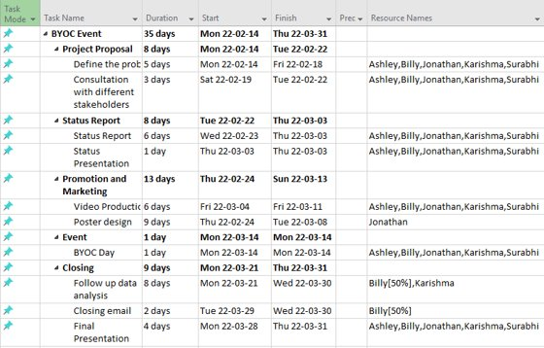

For this project, we divided each activity in response to different deadlines of the course. We set time stamps as project proposal, status report or final presentation and we assigned different sub-tasks in between the time gap of the activities.

**Gantt Chart**

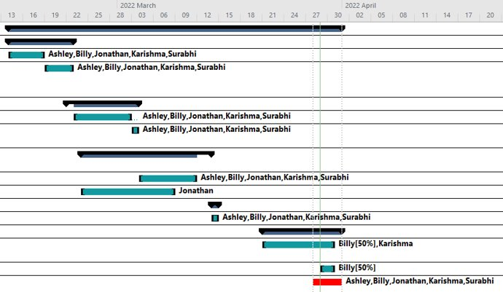

Our project does not have dependent tasks at all. Most of the time we can execute tasks in parallel. As the above Gantt Chart shown, the activity end time is following the deadlines given by the course.

Based on the resources we had for this project, we had great efficiency and action power. We also made critical decisions decisively. If we do not have to follow the deadlines of the course, we can finish that earlier. Hence, shorten the schedule.

## 4.2 Risk Management

There are two risk categories identified, internal and external. For internal risk, we can foresee that there are three possible risks that can reduce our group progress or even end the project, which are listed descending by the severity:

|  |  |  |  |  |
| --- | --- | --- | --- | --- |
|  | Internal Risk | Severity | Chance | Controllability |
| 1 | Project scope is not approved | High | 50% | 0% |
| 2 | Joint event with LSC is not approved | High | 50% | 20% |
| 3 | Team Conflict | Medium | 20% | 95% |

To prevent last minute project scope rejection, we asked for approval at the earlier stage by sending emails to MMC directly before the deadline of the project proposal. Also, we sent our drafted project idea to Shervin to seek advice and comments before the official proposal deadline as well. Even if the idea gets rejected, at that early stage, we can still manage to improve or even change the project problem and luckily, our idea is approved at the end. Also, because of our proactive approach to the key stakeholders, the time saved allowed us to have more time to communicate with stakeholders

To minimize the effect of being rejected on hosting a co-host event between two student associations, we asked for approval on a joint event immediately after we had the consent of Langara Sustainability Club.

To resolve team conflicts, we agreed to the team Code of Conduct, and we are all open to discussing our concerns. If the conflict cannot be resolved by talking out, we will perform voting among the group.

|  |  |  |  |  |
| --- | --- | --- | --- | --- |
|  | External Risk | Severity | Chance | Controllability |
| 1 | Coffee Shops reject to participate | High | 50% | 30% |
| 2 | Government tighten COVID Regulation | Low | 20% | 0% |

We communicated with all three coffee shops in Langara to make sure at least one of them would join the event. Also, we approached different hierarchies of those cafes, from store managers to the General manager of the organization responsible for Langara Cafeteria to make sure we got permission to promote BYOC in Langara community.

We cannot do anything to affect the decision of the authorities, but we can see that the Covid regulations in B.C. are loosening at that time. There are less concerns on this issue.  
  
4.3 Contingency plans

For any reason that we couldn’t host the BYOC event, we got a plan B of hosting a health care knowledge sharing workshop for students.

# 5.0 Other Relevant Information 5.1 An Organizational Change Management Plan

In this project there is no operational change, therefore the operational readiness report or analysis related is not applicable. After the survey, we understand participants would like to use their own cups, but there is no place for washing and under COVID-19 restrictions some coffee cups will refuse to use the customer’s cup for the beverage to minimize the interactions.

## 5.2 Critical Path and Meditation Plan

There are a few critical paths identified during this project, they are:

|  |  |  |
| --- | --- | --- |
| Critical Path Items | What happens if it goes wrong | Meditation |
| Project scope approve | All the planned tasks and schedules need to be replanned according to the new scope. | Walk through the project details with SME and address their enquires. |
| Contact participant | At least one coffee shop joins the event. It will be nothing if no participant. | Ask all the coffee shop on campus, share our idea, and get their consent. |
| Joint Event with LSC | Unable to use LSC offer on filming and their social media channel | Explain the give and take of the joint event with LSC club. |
| Poster on campus | Unable to reach more people to join the event | Understand the approval process and ensure our poster follows the Langara standard. |

5.3 Intended Benefits

The intended benefits are not easy to measure, as the event increases the awareness of environmental protection. It will reduce the production of paper cups and the number of paper cups sent to landfills.

5.4 Project Plan Review

There are not enough details on the project plan for execution as we did not address the joint club event when planning the schedule and tasks at the beginning of the project.

5.5 Agile Methodology Adoption

We applied an agile method to deliver this project as we had meetings with other parties before approval, we execute the task rather than document the functionality, we adopt change quickly when the joint club event is approved.

6.0 Conclusions  
6.1. Project Measurements

There is an online survey with 8 questions that highlights four areas

1. Daily coffee usage (Number of coffee and cup type usage)

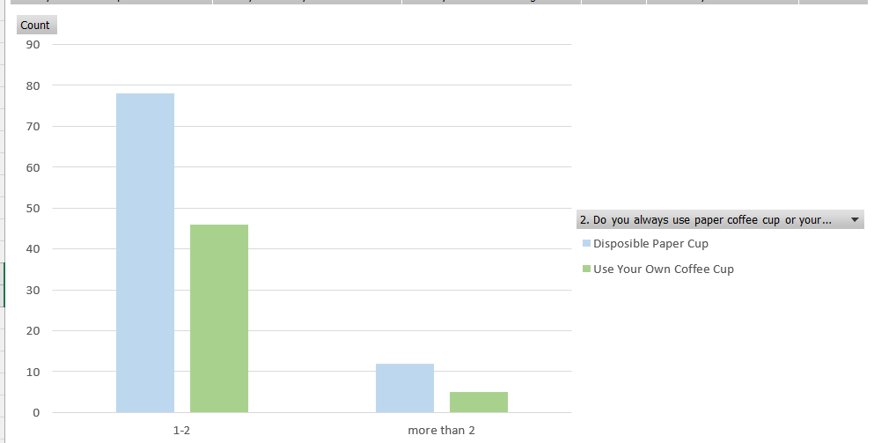

1. Aware of discount, impact of coffee cup and intention to change

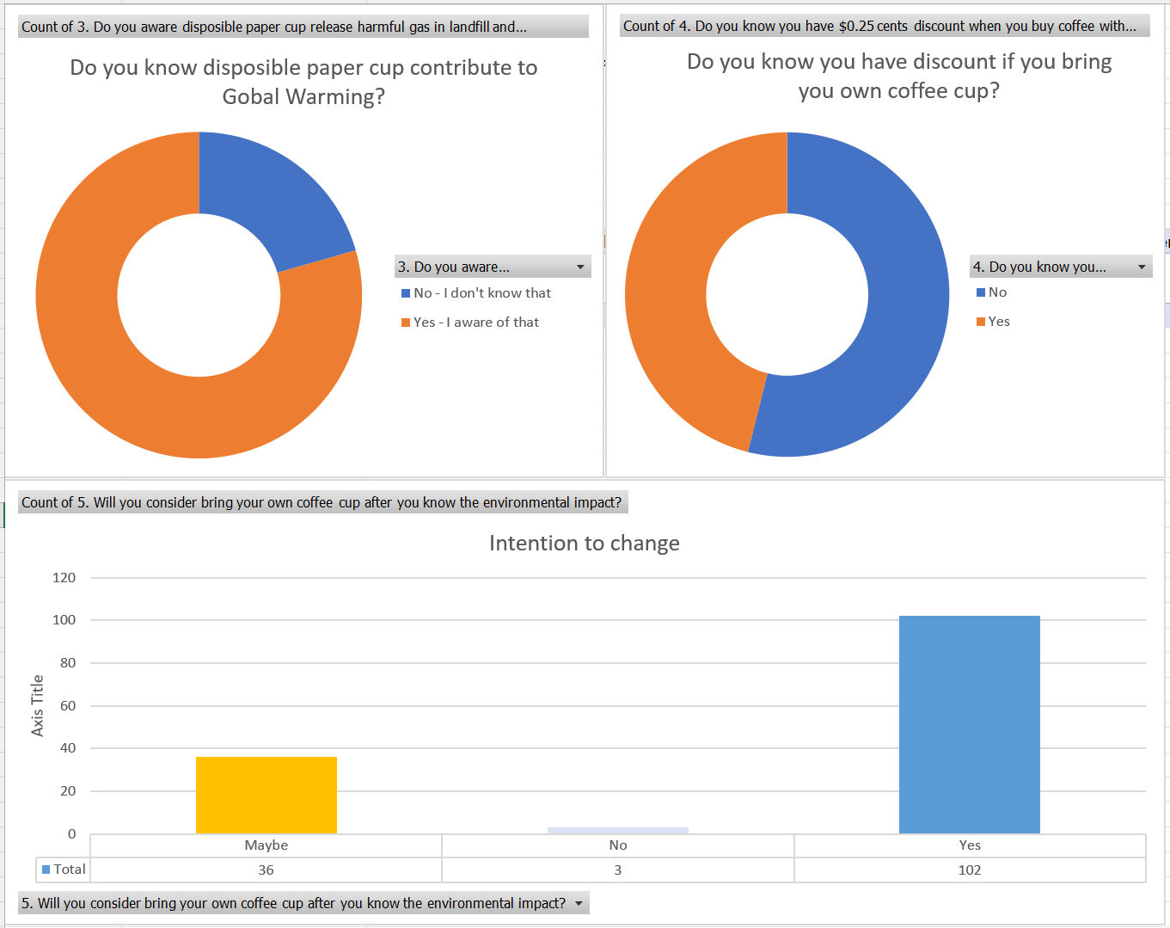

1. Data Collection (gender, staff or student)

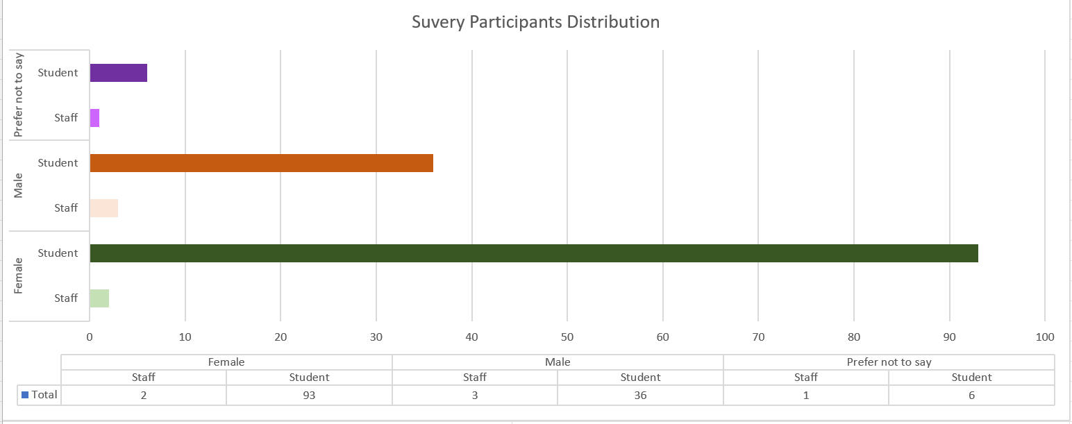

1. Marketing Channel Distributions.

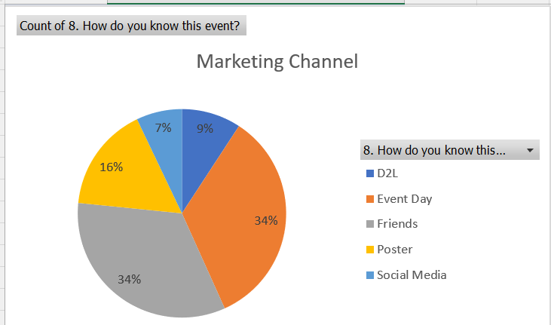

## 6.3. Project Insights

* Stakeholder management, there are different parties and procedures needed for on-going communication for an on-campus event. Our suggestion is start to build the relationship before the project scope is approved.
* Communication plan, there are lots of ways to promote the on-campus event. Our event mainly focuses on message broadcasting via e-channels under COVID. As the restriction is reduced, on-campus booths and posters over the library, main hall and others build may become more efficient.

## 6.4. Key Factor for Project Success

* Assign clear work breakdown structure with clear responsibilities
* Create achievable milestones with the date and regularly review progress
* Define a risk matrix and mitigation plan
* Always have a contingency plan
* Transparent to stakeholders with progress and risk

## 6.5. Lesson Learnt

* There is no centralized department controlling all the notice boards of the campus for our poster, we need to visit individual notice boards owner all over the campus.
* Social media, MMC or LSC social media channels have limited audiences. The promotion can do much better if we can use the Langara social media channels.
* Posters and online surveys are good to broadcast the project goal and collect feedback.
* The survey shows many people are willing to bring their cups, however there is no clean station for cleaning their cups before further usage.

7.0 Bibliography

Chandra, Christina. “You Will Now Be Charged an Extra $0.25 for Single-Use Cups Bought in Vancouver.” YOU WILL NOW BE CHARGED AN EXTRA $0.25 FOR SINGLE-USE CUPS BOUGHT IN VANCOUVER, January 8, 2022. https://604now.com/single-use-coffee-cups-vancouver-extra-charge-2022/.

“Ecological and Social Costs of Single Use Coffee Cups.” Ecological and social costs of single use coffee cups | Open Case Studies. Accessed March 30, 2022. https://cases.open.ubc.ca/w17t2con200-3/.

New bylaws coming into effect on Jan. 1 in Vancouver. CTV News, December 1, 2021. https://bc.ctvnews.ca/new-bylaws-coming-into-effect-on-jan-1-in-vancouver-1.5688336.